Exception

An exception is an event, which occurs during the execution of a program, that disrupts the normal flow of the program's instructions. It is not same as an error exactly

For simplicity, let’s call exception as an error

In java there is actually a class which handles all the exceptions knows as Throwable

We know the main class is the Object class, this object class is inherited by every other class including Throwable

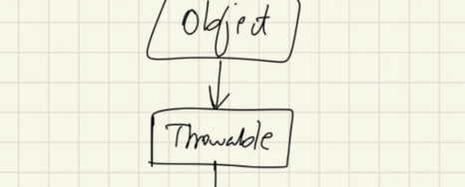

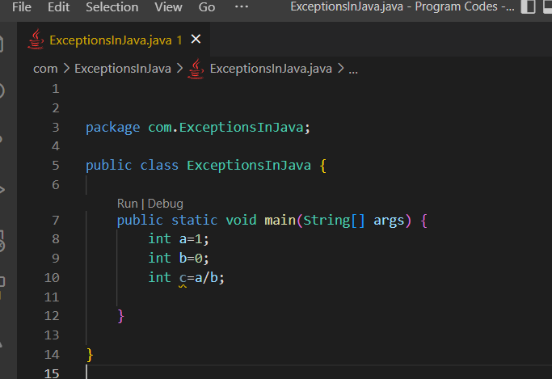

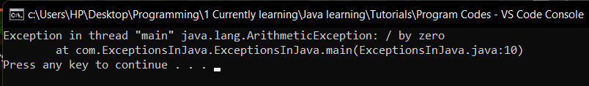

Here it gives us an exception

ArithmeticException to be particular, this ArithmeticException is actually a class in java

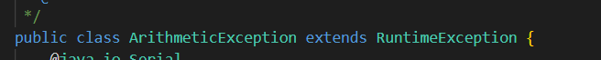

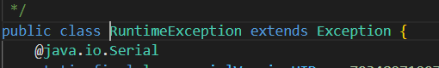

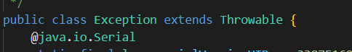

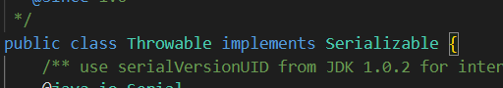

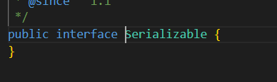

We see ArithmeticException has inherited RunTimeException class which again inherits the Exception class and so on



This error message is looking very ugly so we could try and catch block to obtain error in pretty way

The exception thrown at the execution of blocks of code inside the try { } block is catched by the catch{ } block

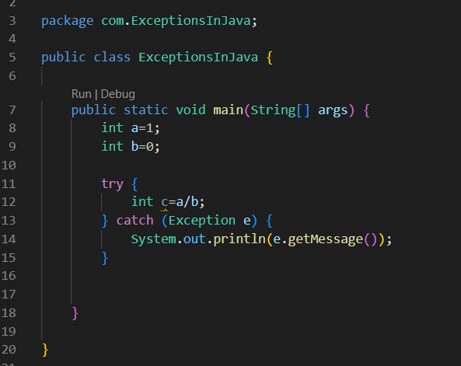

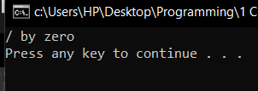 we will get nice error message like this

Here we could have used classes like RunTimeException and ArithmeticException also instead of Exception class, since those are the descendend classes of Exception class

**Most underrated and skipped topic**

Actually this is an underrated concept not only in java but also in other languages, while working heavily with files, data bases, networks we may excessively use the try { }catch() {} and finally { }.

And just these things make things much more simpler and easier to work with

k